Name: _______________________________ Spiral Review - Day 2

Standards
- NBT.5/NBT.6 - I can multiply and divide large numbers.
- NBT.4 - I can add and subtract large numbers.
- OA.3 - I can solve multi-step word problems .

Assessment
- This page will be used to assess previously learned skills and concepts.

Estimate, then find the product  Estimate: ______________________  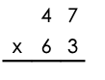 | Estimate, then find the product  Estimate: ______________________  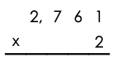
Estimate, then find the quotient  Estimate: ______________________  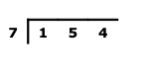 | Estimate, then find the quotient  Estimate: ______________________  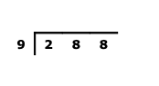
Compute. Show your work.  Rebecca rode her bike 16 miles each day for 30 days. Joe rode his bike 25 miles each day for 28 days. Who rode further? How much further?  Answer:  _______________________________________  _______________________________________ | Compute. Show your work.  All 203 students in the fourth grade at Village School eat lunch at the same time. One day, 19 students were absent. If 8 students sit at each table in the lunchroom, how many tables were used that day in lunch?  Answer:  _______________________________________  _______________________________________

